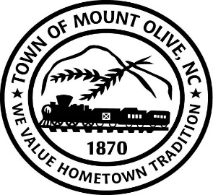
REGULAR BOARD MEETING AGENDA
TUESDAY JANUARY 11, 2022
114 EAST JAMES STREET
7:00 P.M.
I. CALL TO ORDER -
Invocation
Pledge of Allegiance
II. ROLL CALL –
III. READ CONFLICT OF INTEREST STATEMENT -
In accordance with the State Government Ethics Act, it is the duty of every
Member of the Mount Olive Board of Commissioners to avoid both conflicts of interest and appearances of conflict.

Does any member of the Board of Commissioners have any known conflict of interest or appearance of conflict with respect to any matters coming before the Board of Commissioners today?

If so, please identify the conflict or appearance of conflict and refrain from
any undue participation in the particular matter involved.

IV. APPROVAL OF PUBLISHED AGENDA (*Motion/Second-Roll Call)

V. APPROVAL OF MINUTES (*Motion/Second-Roll Call)
a. December 14, 2021 Meeting.

VI. PUBLIC FORUM
Speakers must state name, address, phone number and hold comments to maximum of three minutes.

VII. NON-ACTION MEMO (*Motion/Second-Roll Call)
01-01 – Attorney Carroll Turner will provide a Status Report to the Board Concerning the Following Condemnations:
1) – Old Theater Building at 201 NW Center Street
2) – Old Kraft Building at 104 West James Street
3) - Dove Residence at 107 North Chestnut Street

01-02 – Update on Sidewalk Progress.

01—03 – Annual Fire Department Progress Update

VIII. ACTION MEMO (*Motion/Second-Roll Call)

01-04 – Consider Adoption of the Juneteenth Holiday Resolution
01-05 – Consider Adoption of the Town of Mount Olive 2020 Local Supply Plan
IX. TOWN MANAGER’S REPORT
X. MAYOR AND BOARD OF COMMISSIONERS REPORTS

ADJOURN

