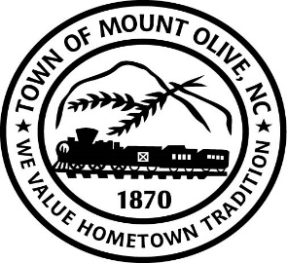
SPECIAL CALLED BOARD MEETING AGENDA
FRIDAY, FEBRUARY 18 2022
110 WEST JAMES STREET
(TRAIN DEPOT)
1:30 P.M.
I. CALL TO ORDER -
Invocation
Pledge of Allegiance
II. ROLL CALL –
III. READ CONFLICT OF INTEREST STATEMENT -
In accordance with the State Government Ethics Act, it is the duty of every
Member of the Mount Olive Board of Commissioners to avoid both conflicts of interest and appearances of conflict.

Does any member of the Board of Commissioners have any known conflict of interest or appearance of conflict with respect to any matters coming before the Board of Commissioners today?

If so, please identify the conflict or appearance of conflict and refrain from
any undue participation in the particular matter involved.

IV. ACTION MEMO (*Motion/Second-Roll Call)

02-18 - Consider Approval of Waste Water Treatment Plant Improvements Project Proposed Soils Work and Professional Services Contract Amendment.
02-19 - Consider Whether To Allow or Not to Allow the Contractor to Install All of the Reclaim Water Lines and Spray Guns in Field 9 for the Mount Olive WWTP Improvements – Contract I Project.

ADJOURN

